**0xDEADBEEF Team Analysis**

Table of Contents

Multiple Intelligences test analysis: 1

My strengths and weaknesses: 1

Team Strength and Weaknesses 2

16 Personalities Test Results – Strengths and Weaknesses 3

My positive traits: 3

My negative traits: 4

My personality type against my group members’ 4

Harrison James Marcks – ENTJ 4

Jesse Batt – ENFP 4

Dan Steer – ISFJ 4

Overall comparison 5

Team Roles analysis: 5

My strengths and weaknesses 5

My teams score 5

Bibliography 6

Appendix 6

# Multiple Intelligences test analysis:

I will start by looking at the positive scores gained in multiple intelligences test and explain how these would be beneficial for team work environment.

## My strengths and weaknesses:

Upon the completion of the multiple intelligences test, I discovered my strongest trait was interpersonal skills. Common interpersonal situations include directing, counselling, coaching, praising, disciplining, training, problem solving and many others (McConnel, 2004). Such skill will enable me to communicate and interact well with my group members. I will be happy and confident to direct the project and solve other team member’s problems. These useful traits on top of my positive and down to earth nature will make me very approachable for questions, feedback or even criticism during group work.

My second highest intelligence was logical-mathematical intelligence. This intelligence is related to reasoning, logic and critical thinking. I am able to understand systems and patterns, solve problems and make practical and logical decisions. Our project begins with heavy load of paper work and documentation. Most of us are not familiar with such workflows as our current experience relies on practical approach to a problem. In such situations, I will be able to offer logical suggestions as to how we should approach certain tasks and distinguish what we should prioritise to achieve the most marks.

My lowest result is scored on the spatial-visual intelligence. This intelligence includes space relations and visualisations. This score means that I can potentially struggle to visualise other people’s ideas and opinions. Mcsorley (2014) states that people with high spatial-visual intelligence have a tendency of learning materials quickly and easily when it is presented to them. Having scored low on this part, I might need extra time to grasp a new concept or ideas presented to me.

When a new idea or material is presented to me, I like to go over as many potential outcomes as possible whether its positive or negative. In my observations, Jesse and Harry are both quick to make assumptions and decisions. When a certain material is presented to them, they tend to focus on one aspect of it, and thus make hasty decisions. Sometimes this is a useful trait to have in a team as it could speed up decision making and therefore the entire speed of work. However, I tend to take a broader look at the subject and try to draw conclusions. This could affect the team in a negative and positive way. I could potentially slow down the team when a new idea or resource is introduced, but, once I draw my conclusions around it, I can offer more objective and elaborate points which the team might have missed in the first place.

## Team Strength and Weaknesses

I have merged the teams overall score into a line chart in order better visualise our strengths and weaknesses.

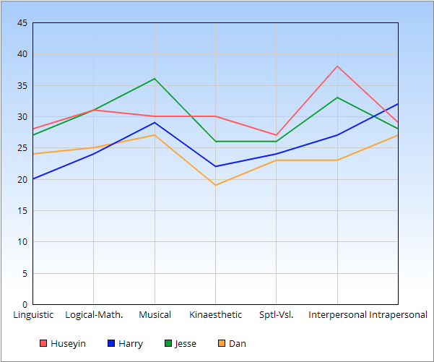

Looking at this line graph, we can see that we scored low on the following:

* Linguistic
* Bodily-kinaesthetic
* Spatial-visual

Having a low linguistic skill across the team could bring some negative outcomes. We could struggle to put our ideas and thoughts across to each other. This could result to loss of some great ideas and potentials. Moreover, we can end up misunderstanding each other, potentially upsetting one another.

Next, having low spatial-visual intelligence could result in members not being able to effectively visualise other team member’s ideas and opinions. This again could result in some conflicts as your team members might look over some of the points you raise and deem them impractical. Such situation could result in some members being felt left out.

On the plus side, we can see a positive correlation on the interpersonal skills. This is good news as it shows we all possess skills and mind-set to work effectively and productively in a team. We are all adaptable and open to negotiation. If any conflict were to arise, we could speedily resolve the conflict and bring the matter to an end before it elevates.

Another trait that also comes along with interpersonal skills is self-awareness. When tasks are being assigned to members, they will each pick an area of their own expertise or skillset and tackle it to the best of their ability.

# 16 Personalities Test Results – Strengths and Weaknesses

According Myers Brigg’s “16 Personalities” test, I am a ENFJ which stands for Extraversion, Intuition, Feeling and Judgement.

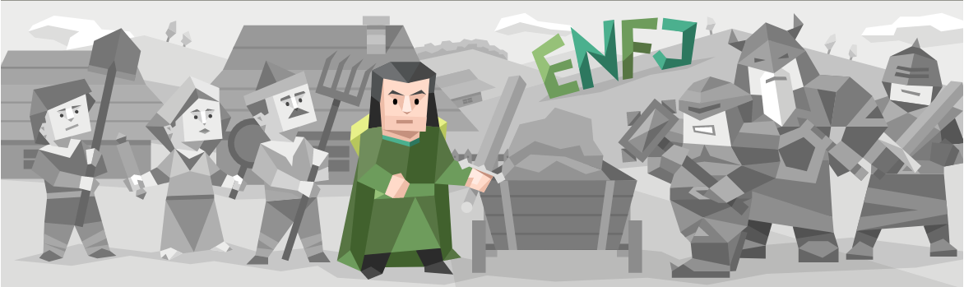

## My positive traits:

One of my strengths is being reliable. I do not like the idea of letting a person down and I can always be counted on. This is an extremely useful trait to have especially when you are working in a team. Team members can count on me to finish tasks before deadlines thus relieving them of stress.

Other strengths that I possess are altruism and tolerance. I am selfless and want the best for everyone. If a conflict occurs between team members, I am likely to act rationally, listen to each team members carefully, tolerate some of their behaviour and try to bring the conflict to an end before it gets out of control.

## My negative traits:

First weakness on the list is being too selfless. I could end up burying myself in hopeful promises and stress myself out trying to meet my word or spend too much time worrying about other people’s problems. I could increase my own workload by needlessly trying to help others and end up putting unnecessary pressure on myself.

Another weakness of mine could be my sensitivity. While I am good at taking criticism as it is a great tool for my leadership skills, I can often pile up feelings that I may deem not too important to speak out about, but deep down know its bothering me. I should speak up about anything that makes me feel uncomfortable and let team members know how I feel there and then.

## My personality type against my group members’

### Harrison James Marcks – ENTJ

Harry and I have very similar characteristics. The only the only conflicting characteristic is his ‘thinking’ against my ‘feeling’. The ‘thinking’ partner may be impatient when dealing with the emotions of the ‘feeling’ partner and may come across as rude or condescending. To counter this, I should not take their actions personally and assume the other side means well. Meanwhile, Harry should also not be hasty in dismissing my feelings as insignificant or overreactions. This will need tolerance on both side, but once it is achieved, with the help of other characteristics we will work well with each other.

### Jesse Batt – ENFP

Just like with Harry, I share common traits with Jesse. However, again, there is a single difference between our personality types which is my ‘judging’ against his ‘perceiving’. I am organised and place strong value in time management and accountability. The ‘perceiving’ type can be laid back unorganised. They may not be able to stick to a plan or not fulfil their promises. If such occasion was to occur, I should take things slowly and not let anger take over my criticisms. We should meet halfway between the spontaneous chaos of perceiving and the strict order of the judging and understand we never want to deliberately hurt each others feelings.

### Dan Steer – ISFJ

Dan is the only introvert in our group. He may struggle to voice out his opinions in a group full of extroverts. However, I will use my leaderships skills to listen to everyone and make sure that everyone has a voice. If I feel that a member is being left out, I will bring attention to such matter and ensure that they are not isolated. Dan and I also share ‘feeling’ and ‘judging’ characteristics. My extroversion could help me voice out the feelings of my introverted partner as we occasionally share same feelings. We also like having things settled, planned and organised so it should be good experience to work together.

## Overall comparison

There are three members in the group which possess the ‘feeling’ characteristic. We can all be quite sensitive and take things personally. However, we are all friendly and loyal. We have also known each other since year one and worked on same projects before. This friendship experience will enable the ‘feeling’ types to understand other members more accurately and stop them from overthinking about playful jokes.

# Team Roles analysis:

Strongest team role I have according to the Belbin’s Team role test is ‘team worker’ with 23 points. This is followed by ‘resource analyst’ and ‘completer’ with 14 points. Check Appendix for all scores from all members.

## My strengths and weaknesses

First result matches with my previous test results and once again proves that I work well in a team. According to the Belbin’s theory, this trait makes me easy to get along with other people as previous test results confirm. However, it also states that I can be indecisive and hesitant to make unpopular decisions. This can be true as I often take the road I know as opposed exploring new paths.

Next, my analyst and completer characteristics show that I am outgoing, enthusiastic, polisher and perfectionist. However, I can be over optimistic and begin to lose interest when the initial enthusiasm has passed. I can also be reluctant to delegate or take my perfectionism to extremes which could slow the workflow. I need to make sure that I focus on the priorities we set out and not worry about insignificant parts of the system.

## My teams score

As a team, we have well rounded team roles evenly spread between us.

For instance, Jesse, Dan and I seem to be lacking the ‘expert’ quality which Harry possesses. On the other side, Harry and Jesse seem to be lacking the ‘completer’ quality whereas Dan and I seem to be quite strong in that team role. We can ensure that tasks are finished and organised before moving on to other tasks.

Harry and Jesse also scored low on team worker role which contradicts the score relating to their interpersonal skills we discussed earlier. Again, me and Dan scored high on team worker role so we can bring the team together and create a friendly working environment for everyone. We can also share the workload equally between team members ensuring that there is no member with lots or little to do.

We also seemed to score high on the ‘innovative’ role. This means that we are open and welcoming to new ideas. We could explore new ways of approaching tasks and try methods that no other team has tried. Although this would personally conflict with my inflexible, ‘guaranteed to work’ work ethic, it will allow me to explore new paths which could potentially put us at great advantage against other teams.

# Bibliography

Anon. (2018) *Personality Type Compatibility* [Online]. Available from: <http://www.personality-type.net/compatibility/> [Accessed 17 November 2018].

Anon. (2018) *The Nine Belbin Team Roles* [Online]. Available from: <https://www.belbin.com/about/belbin-team-roles/> [Accessed 17 November 2018].

McConnel, C.R. (2004) Interpersonal Skills What They Are, How to Improve Them, and How to Apply Them. *The Health Care Manager*, 23(2), pp.177-87.

Mcsorley, B. (2014) *Udemy Blog* [Online]. Available from: <https://blog.udemy.com/logical-mathematical-intelligence/> [Accessed 8 October 2018].

Appendix

Huseyin Sert

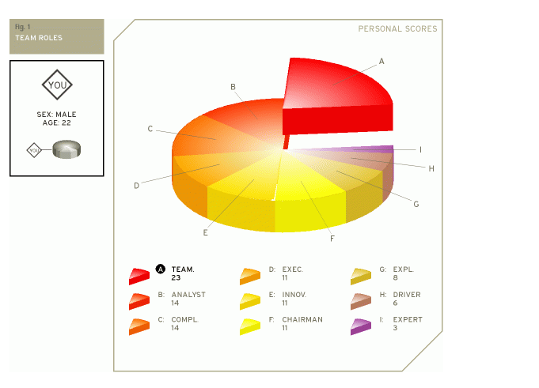

Harrison James Marcks

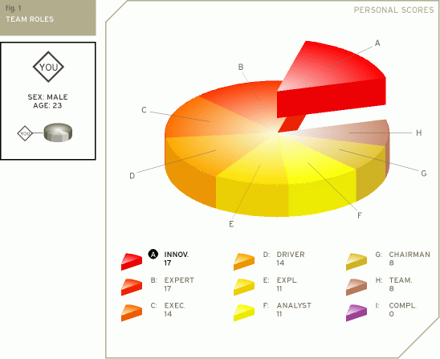

Dan Steer

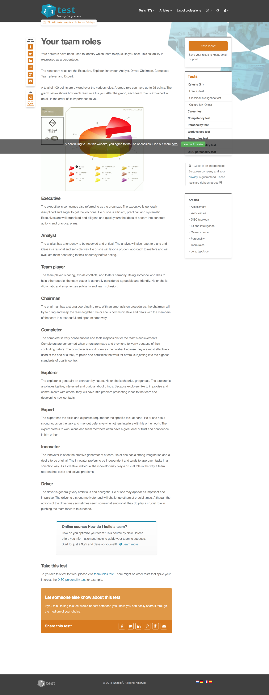

Jesse Batt

